Meets Specifications

**You are doing very well!**

Congratulations on your job and good luck with the next! :)

**Submission Phase**

**A PDF report has been uploaded and a excel workbook has been uploaded in a single zipped folder file**

**Very good!**  
Received PDF report and excel worksheet.

**Exploration Phase**

**The project clearly states four or more questions, then addresses those questions in the rest of the analysis. The solutions to the questions should range in being found from a single column to being found using multiple columns.**

**At least one question/solution must make use of multiple columns.**

**Very well!**  
You do analysis using one column and also using multiple.

Is very important to make the right questions. This [post](https://towardsdatascience.com/start-your-data-exploration-with-questions-2f1d42cff29e) is a great reading on this subject.

**Student uses means, medians, and modes to generate insights.**

**Stating the mean, median, and mode is insufficient. Please include in the written description a short insight related to each one.**

**For example here is an insight based on median:  
The median number of hours slept by survey respondents who were employed was 4 hours. The median number of hours slept by unemployed survey respondents was 12. It looks like those who are unemployed get much more sleep based on the median.  
(this data is fake for this example)**

**Excellent!**  
You use the central measures to obtain insights and observations.

This [link](http://www.abs.gov.au/websitedbs/a3121120.nsf/home/statistical+language+-+measures+of+central+tendency) is great to learn a litle more about this subject.

**Student uses standard deviation and range to generate insights.**

**Stating the standard deviation and range is insufficient. Please include in the written description a short insight related to each one.**

**For an example, please review the finished slide example in the classroom, which can be found in the Analyze Survey Data project lesson (concept 7: Finished Example Slide).**

**Excellent!**  
You use the standard deviation measures to obtain insights and observations and give a clear definition about it.

**Student uses at least two different plots to explore the data. These plots may include histograms, box-plots, scatterplots, and bar charts to explore data and gain insights.**

**All slides must contain a visualization. Screenshots of values in a table does not count.**

**Good job!**  
You use different graphs to display different values in many points of view. Congratulations!

Graphics are very important in data analysis. They can give life to the information we want to get through. Graphics talk. :)

If you have questions about which chart to use in each situation, this [link](http://www.tableau.com/sites/default/files/media/which_chart_v6_final_0.pdf) can be very useful.

The image below is also great for helping you choose the best graphic style:  
[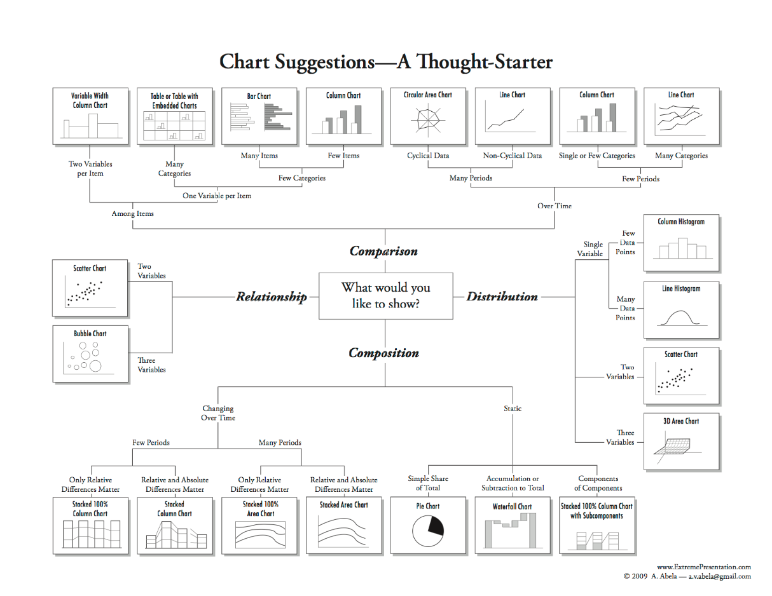](https://udacity-reviews-uploads.s3.us-west-2.amazonaws.com/_attachments/48035/1524438454/charts.png)

**An appropriate visual is chosen to present the data. All labels are legible and the visual has appropriate axis labels.**

**Every visualization should have**

* **chart title**
* **x axis title**
* **x axis labels**
* **y axis title**
* **y axis labels**

**Please refer to the finished slide example page in the classroom for an example.**

**Excellent!**  
Graphics should be of immediate interpretation and the inclusion of titles, captions and descriptions of the axes are essential for this.

**Communication Phase**

**The results of the analysis are presented such that any limitations are clear. The analysis does not state or imply that one change causes another based solely on a correlation.**

**The results do not imply facts about a larger group of individuals based on descriptive values. Language is only applied to the specific data provided. Unless a correct analysis beyond the course material is conducted that allows for inference.**

**This data is from Survey Respondents and is not from the entire Udacity Student population. This must be acknowledged at least once in the submission.**

**Good analysis and conclusions!**  
You show the observations very well.

And you write explicitly that these data are of research participants and do not represent the full body of students of Udacity.

**The analysis associated with answering a particular question uses the appropriate variables, summary statistics, and plots that could provide an answer.**

**Very well!**  
The graphics are adequate and consistent.